Feature 6: Maintenance Management
Project Name: RentSure |  |  |  | Test Designed by: Jannatul sadia
Test Case ID: TC-MNT |  |  |  | Test Designed date: 23-12-2025
Test Priority (Low, Medium, High): High |  |  |  | Test Executed by: 01-01-2026
Module Name: Maintenance Management |  |  |  | Test Execution date: 01-01-2026
Test Title: Request submitted;
Description: Verify Tenant can submit a valid maintenance request
Precondition: Tenant logged in; Active rental
Dependencies:
- Authorization Module (User login functionality)
- Rental Management Module (Active rental contract required)
- Property Management Module (Property must exist in system)
Test Steps | Test Data | Expected Results | Actual Results |  | Status (Pass/Fail)
- Go to Maintenance  - Select property  - Discribe issue  - Give image if have | Water leakage | Request submitted; | As expected |  | Pass

Test Case ID: TC-MNO |  |  |  | Test Designed date: 23-12-2025
Test Priority (Low, Medium, High): High |  |  |  | Test Executed by: 01-01-2026
Module Name: Maintenance Management |  |  |  | Test Execution date: 01-01-2026
Test Title: Owner filters requests
Description: Owner updates status to In Progress. Owner marks request as Resolved, View Maintenance History.
Precondition: Owner logged in; Multiple requests
Dependencies:
- Authorization Module (Owner authentication required)
- Rental Management Module (Owner must have active rental properties with tenants)
- Maintenance Management Module (Maintenance requests must exist in database)
Test Steps | Test Data | Expected Results | Actual Results |  | Status (Pass/Fail)
- Go to Reports | Status: Pending | Filter by Pending | As expected |  | Pass
- Click Update Status  - Make it in progress | In Progress | Tenant notified | As expected |  | Pass
- Make it Resolved | Resolved | Tenant notified | As expected |  | Pass

Feature 7: Communication
Project Name: RentSure |  |  |  | Test Designed by: Jannatul sadia
Test Case ID: TC-COM |  |  |  | Test Designed date: 23-12-2025
Test Priority (Low, Medium, High): High |  |  |  | Test Executed by: 01-01-2026
Module Name: Communication |  |  |  | Test Execution date: 01-01-2026
Test Title: Chat message
Description: Send chat message, Load chat history
Precondition: Tenant logged in;
Dependencies:
- Authorization Module (User login functionality)

Test Steps | Test Data | Expected Results | Actual Results |  | Status (Pass/Fail)
- Go to Chat  - Find person to massage  - Send massage | hi….. | Message send | As expected |  | Pass
- Load history | N/A | History loads | As expected |  | Pass

Feature 10: Admin Management
Project Name: RentSure |  |  |  | Test Designed by: Jannatul sadia
Test Case ID: TC-COMA |  |  |  | Test Designed date: 23-12-2025
Test Priority (Low, Medium, High): High |  |  |  | Test Executed by: 01-01-2026
Module Name: Admin Management |  |  |  | Test Execution date: 01-01-2026
Test Title: Manage Users [Admin]
Description: As an admin, I want to view and manage all users in the system.

Precondition: Admin logged in;
Dependencies:
- Authorization Module (User login functionality)

Test Steps | Test Data | Expected Results | Actual Results |  | Status (Pass/Fail)
- Go to Manage User  - Find person to message  - send message | hi….. | Message send | As expected |  | Pass
- load history | N/A | History loads | As expected |  | Pass
- so to settings bar  - Bolck the user. | Block | Block user | As expected |  | Pass
Test Case ID: TC-ADM |  |  |  | Test Designed date: 23-12-2025
Test Priority (Low, Medium, High): High |  |  |  | Test Executed by: 01-01-2026
Module Name: Admin Management |  |  |  | Test Execution date: 01-01-2026
Test Title: Manage property
Description: As an admin, I want to verify new property listings to ensure legitimacy.

Precondition: Admin logged in, Pending property listings
Dependencies:
- Authorization Module (Admin authentication and login required)
- Property Management Module (Property listings database with pending status)
- Database connection (To retrieve, update, and filter property listings)
- File Management Module (To access property images and documents)

Test Steps | Test Data | Expected Results | Actual Results |  | Status (Pass/Fail)
- Go to Manage property | New Apt 48 | Filter by Pending | As expected |  | Pass
- View the pending property  - If all okay approve the request | New Apt 48 | Mark as Approve | As expected |  | Pass

Test Case ID: TC-ADMC |  |  |  | Test Designed date: 23-12-2025
Test Priority (Low, Medium, High): High |  |  |  | Test Executed by: 01-01-2026
Module Name: Admin Management |  |  |  | Test Execution date: 01-01-2026
Test Title: View Complaints [Admin]
Description: As an admin, I want to view and resolve complaints reported by users.
Precondition: Admin logged in; Multiple complaints exist in system
Dependencies:
- Authorization Module (Admin authentication and login required)
- User Management Module (To identify and retrieve complaint submitter information)
- Complaint Management Module (To retrieve and store complaint records)
- Database connection (To retrieve, filter, and update complaint records and remarks)

Test Steps | Test Data | Expected Results | Actual Results |  | Status (Pass/Fail)
- Go to Complains  - Check the Pending complains  - Mark as solved | Window broken | Mark as solved | As expected |  | Pass

Step 1: Clone the Repository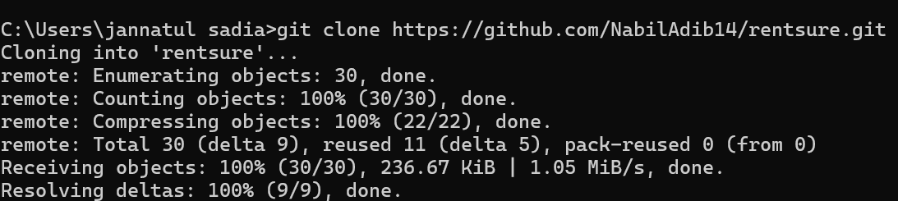
Step 2: Create Feature Branch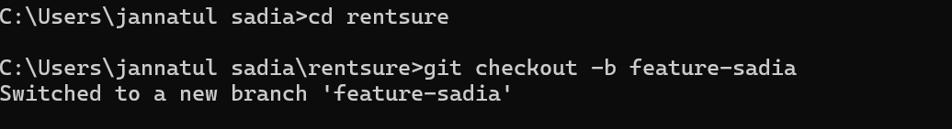
Step 3: Adding all Assigned Tasks 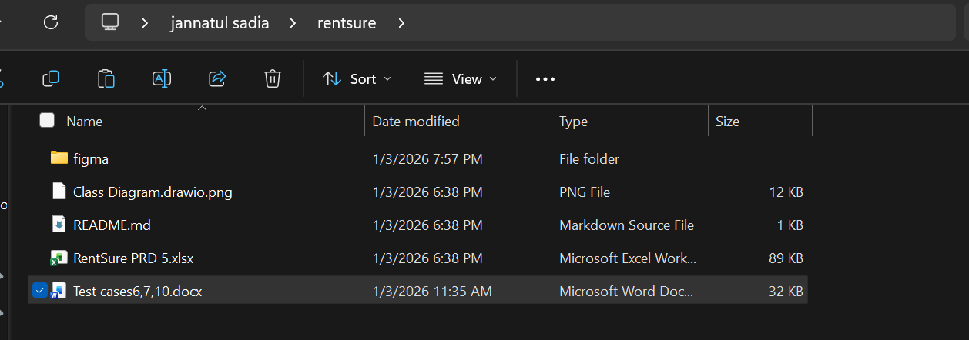
Step 4: Stage and Commit Changes 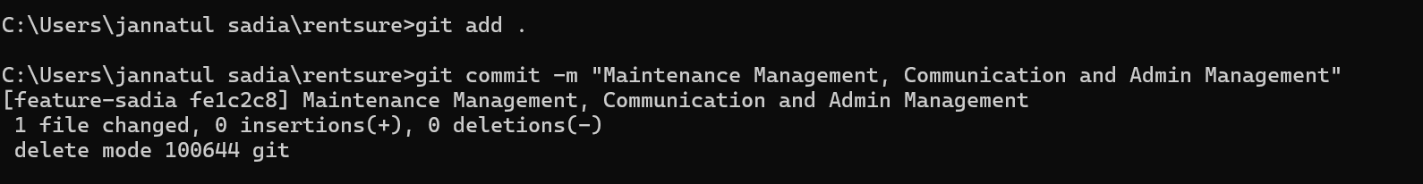
Step 5: Push Branch to GitHub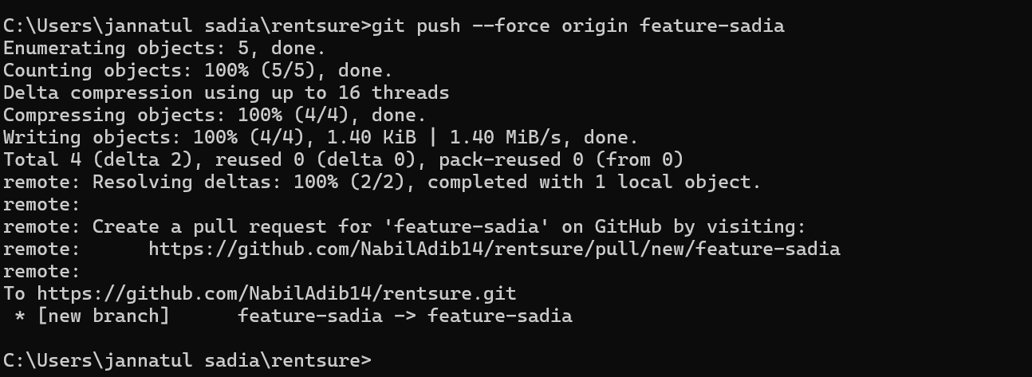
Step 6: Stay Updated with Main Branch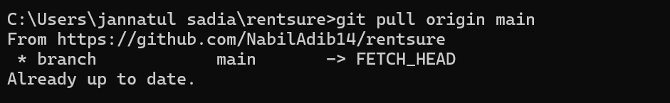

Step 7: Create a Pull Request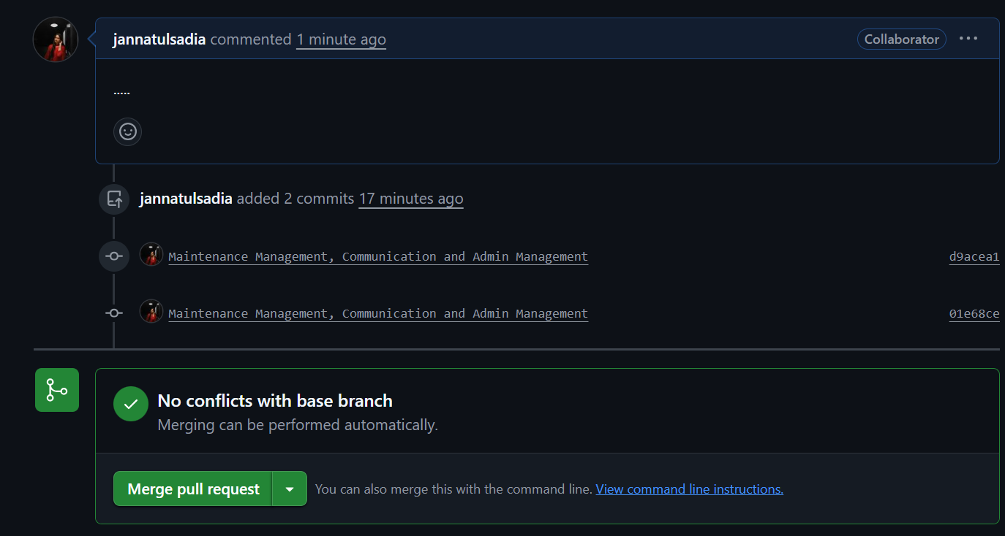
Step 8: Merge After Review